RNA ANALYSIS  
  
Genes:

TCH3 (TOUCH 3). Locus : AT2G41100 (Touch, absence of light? temp)

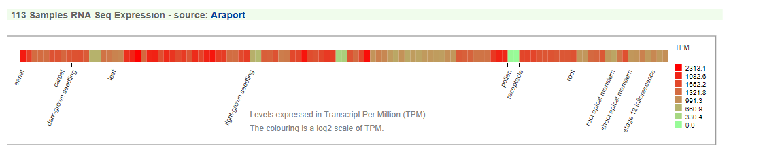

MPK3 ( MITOGEN-ACTIVATED PROTEIN KINASE 3) Locus: AT3G45640

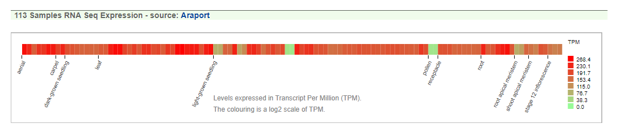

CBP60G (CAM-BINDING PROTEIN 60-LIKE G) Locus: AT5G26920 (also in cold?)

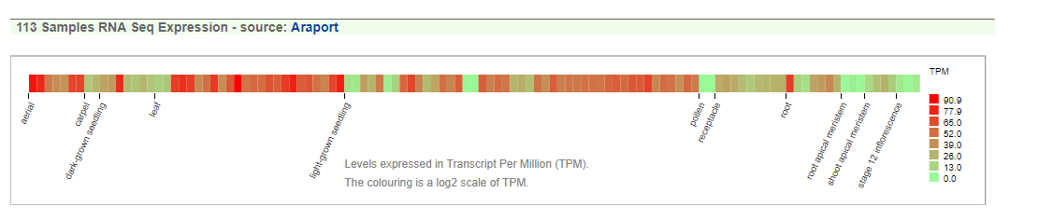

3/13/18

Made RLT- βME

Added 2 beads to flight 2 samples (4,5,6,10,11,12,16,17,18)